
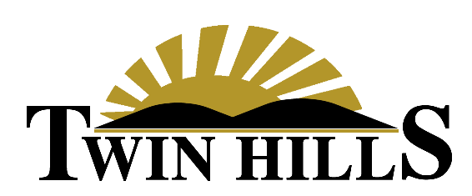

Subject: Important Changes to Food Minimum Requirements and Billing Cycles
Dear Valued Members,
We are writing to inform you of important updates to our club’s food and beverage minimum program. These adjustments are designed to ensure the continued excellence of our culinary operations and, crucially, to simplify the administrative process for every member.
Re-alignment of Monthly Food Minimums
We are implementing a revised and corrected monthly food minimum schedule. The process of correcting and updating all member accounts to reflect the figures below is beginning immediately. This action is being taken to properly re-align the required minimum expenditure with the actual privileges and intended amounts for each membership category, correcting previous inconsistencies in the structure.
Please note that these minimums apply only to food purchases. Beverage purchases, including alcoholic and non-alcoholic drinks, do not count toward meeting your minimum requirement. We encourage you to use your minimum to explore the fantastic menus and dining specials crafted by our culinary team.
Below is a breakdown of the corrected monthly food minimums:
Membership Level | Monthly Food Minimum
Family | $75
Single | $55
Young Executive Family | $50
Young Executive Single | $35
Junior Family | $40
Junior Single | $25
Social | $25

Alignment of the Minimum Usage Cycle
We understand that the club’s previous system for tracking the monthly food minimum, which utilized four different cycle dates based on the first letter of a member’s last name, was confusing for both members and our staff. It also did not align with billing cycles, which added to the confusion on statements.
The previous staggered schedule was:
- Last Names A–D: 1st of the month through the 31st
- Last Names E–K: 7th of the month through the 6th of the following month
- Last Names L–R: 14th of the month through the 13th of the following month
- Last Names S–Z: 21st of the month through the 20th of the following month
This complexity often led to confusion regarding when a cycle began and ended, particularly when scheduling events or planning family meals at the club.
In an effort to make the program completely transparent and less complicated for all involved, we are moving to a universal, standardized cycle. Effective January 1st, 2026, the monthly food minimum cycle for all members will be the 1st day of the calendar month through the last day of the calendar month (e.g., January 1st to January 31st).
This change means every member will operate on the same, easy-to-remember cycle, simplifying accounting, matching the statement cycles, and making it straightforward to track your usage.
We appreciate your understanding as we implement these necessary changes. Our goal is always to improve the member experience and continue providing exceptional service and dining options.
If you have any questions regarding your new minimum or the cycle change, please contact the Membership Office at 417-623-4112
or events@twinhillsgolf.net.
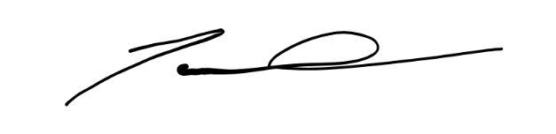
Sincerely,

Jared Whitehead
Twin Hills Golf & Country Club
Club House Manager

